Information Problems- Azrieli & Sons Trucks
- Problems that must be issued:
  - Irregular velocities- around 220 km/h and around 10 km/h.
  - Total income problem:
    - What do you consider as weekends? Nights?
    - The strat_time, end_time and km are not enough information for the income calculation.
    - Missing values in end_time & start_time – would be problematic for calculation of the night bonus.
    - Both end_time & start_time missing
- Taarif:
- Missing all values for bituach leumi
- Missing extra_milage for electricity
- Customers that are not on the taarif: hot, yes, aminach
- Anomaly value in electricity weekend_bonus- 70,000

- Problems that require clarification:
  - Vetek- is it in years for drivers_with_kviut.csv and in days for new_drivers.csv?
  - Is birth day of 1/1/1900 a placeholder? If so, what would you like to see in the summary?
  - Gender- would you want me to copy the exact gender from the driver information csvs? Or should I normalize all genders to a single convention?

- General (Fixable) issues:

- trips_data:
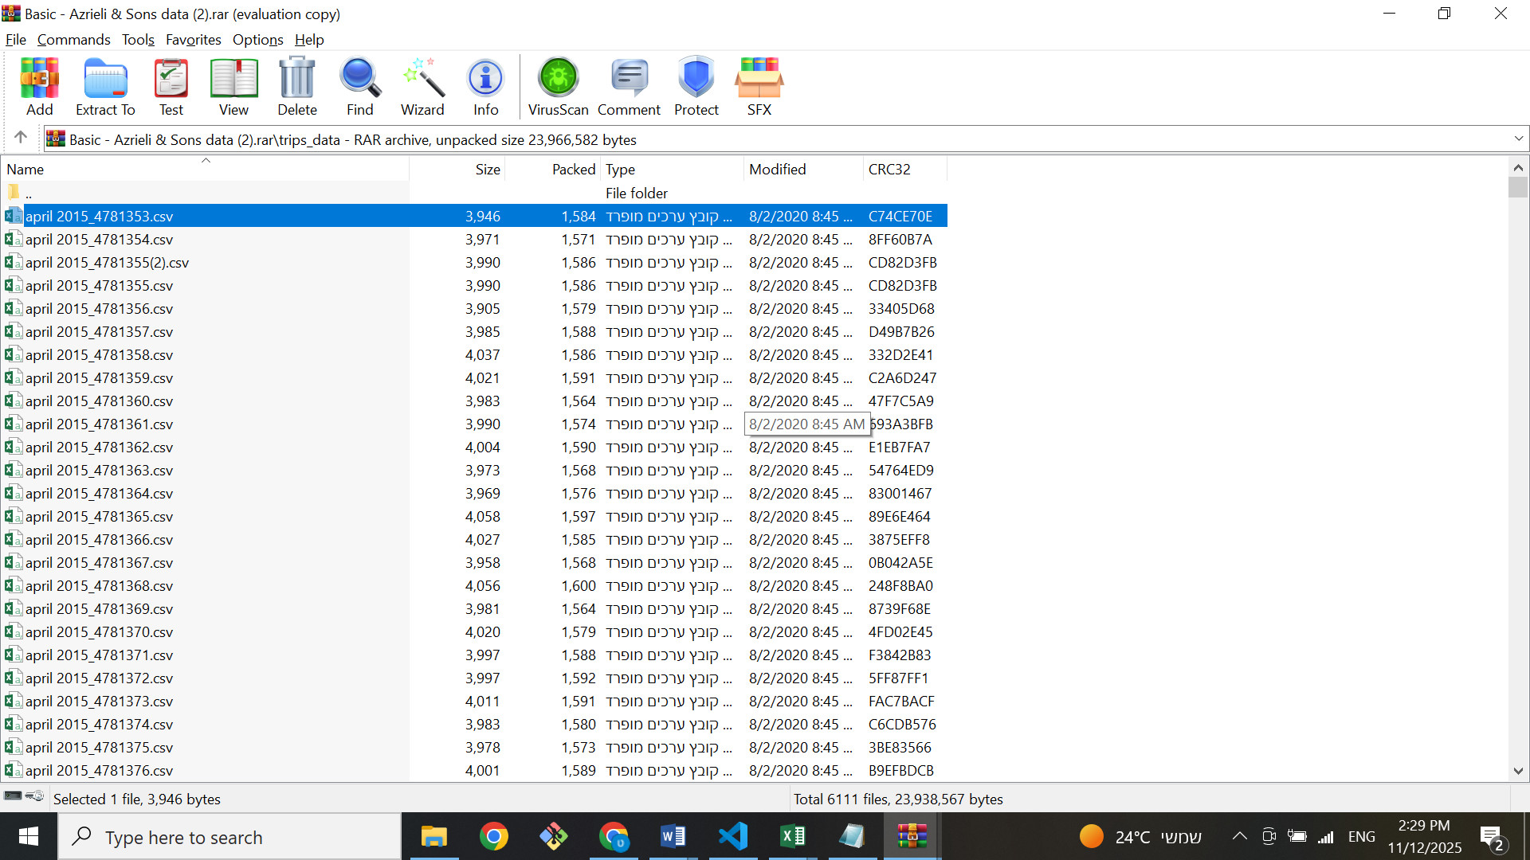
  - Some files are duplicated: (they are equal)
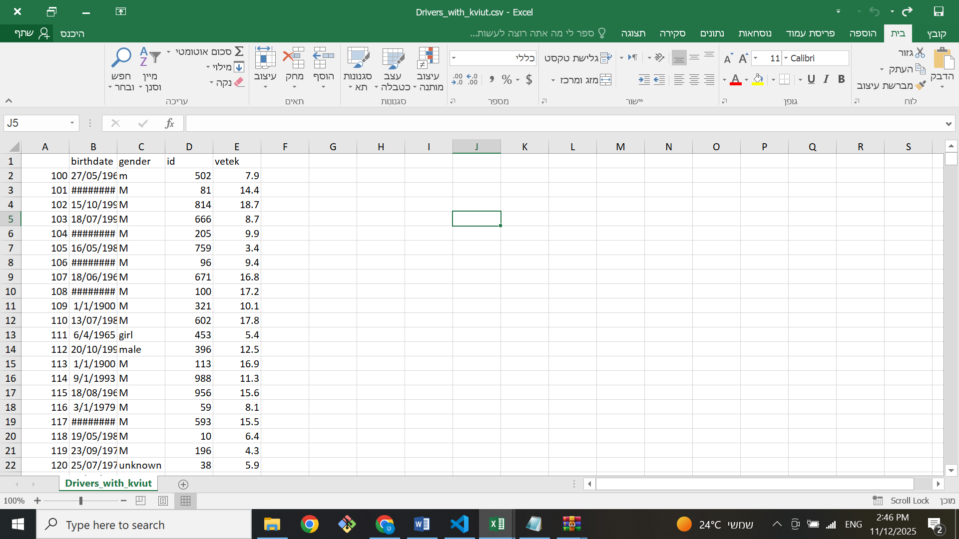
- Drivers_with_kviut:
  - Gender convention changes:
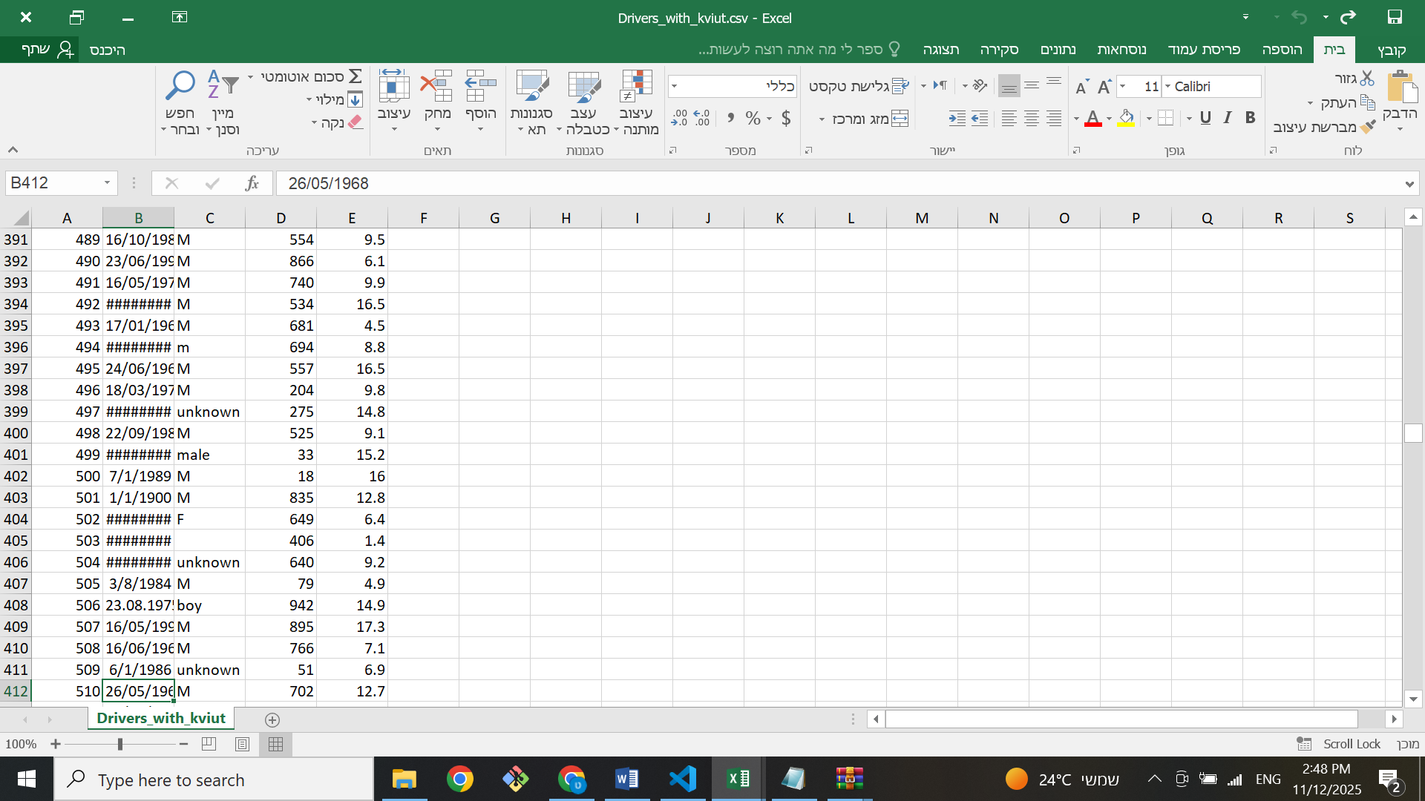
  - Birthday convention changes:

